The Belief in a Supreme Being?

Harvey Lovewell

WHJ Mayers Centre of Masonic Education and Knowledge.

For ANZMRC Conference 2022

Dunedin.

Contents
Introduction: 3
Supreme Being. 4
Various Ideas of a Supreme Being/God. 4
Words. 6
Moral Compass: 6
Belief: - 7
Religion: - 8
Ideology: 9
Philosophy. 10
Philosophy 10
Freemasons Constitutions 11
The volume of Sacred Law 15
What is an Oath/Vow? 17
Who are believers? 17
The Questions we need to ponder. 19

.

Introduction:
I have addressed the theme “Beyond the Craft” by selecting this subject, as I think we must look beyond our present ideas of Freemasonry as we know it if we are to survive.
This paper looks at the condition within our constitutions for the belief in a Supreme Being, as a requirement for membership of our order. Why do we ask this? Is it to demand that a man who has a high moral compass should be welcomed? Are we saying that only a belief in a Supreme Being can give a man this high moral compass? History has shown that men with no morality who were outright evil have believed in a Supreme Being.
I ask the question. Should Freemasonry's use of Volumes of Sacred Law also be reconsidered?.
I will investigate published data to show society's beliefs and how these have changed.
I claim that this is not a discussion on religion but a discussion of the concept of belief, including an analysis of some parts of Freemasonrie’s constitution and how it affects Freemasons.
I have also used the term “our constitution”, in essence, the constitution of the UGLE, as ours is based on this.
I ask the questions that I think we Freemasons, as a Fraternity, should be trying to answer.
I acknowledge the controversial nature of the subject but claim that is the role of our organisation. I also acknowledge that there are constraints on the length of this paper so in-depth discussion has been avoided.
“If you would be a real seeker after truth, it is necessary that at least once in your life you doubt, as far as possible, all things” – René Descartes
And from Bertrand Russell. Quoted from Fact and Fiction 1961
“Truth is a shining goddess, always veiled, always distant, never wholly approachable,
But worthy of all the devotion of which the human spirit is capable”

Supreme Being.
So, what then are we able to define as a supreme being? The concept of a supreme being starts with a sense that “something” must be responsible for the world around us. The idea of a creator is key and this creator requires worship (i.e., an acknowledgement of human dependence on and love for the creator). It is this combination of creator and worship that drives most religious traditions to monotheism. Even in Hinduism, with many Gods and Goddesses, there is still an emphasis on the underlying unity of the many in the one Brahma the reality and truth as seen by Hindus.
Humans like to attribute causes to events and attempt to understand what is taking place around them. This is why individuals have been using religious ceremonies for centuries to invoke the will of the gods – because they believed the gods controlled certain elements of the natural world (e.g., the weather).

Various Ideas of a Supreme Being/God.
Some day, when the cloud of prejudice has been dispelled by the searchlight of truth, the world will honor Masonry for its service to freedom of thought and the liberty of faith. No part of its history has been more noble, no principle of its teaching has been more precious than its age-long demand for the right and duty of every soul to seek that light by which no man was ever injured, and that truth that makes man free.
Masonic Philosophy by Joseph Fort Newton
So where to stand? The idea of a Supreme Being and its discussion fills many thousands of volumes and deep analysis is beyond the scope of this paper, but to touch on it I must.
Supreme Beings are divinities whose nature reveals a unique quality of being—generally, a transcendent spiritual power—in a culture's religious system.
Various cultures have their idea of a Supreme Being and a belief in such is strongly rooted in their culture, tribes on all continents have their versions. However, what we know of what is termed major religions can be shown by the following diagram. They all end up with the same God,
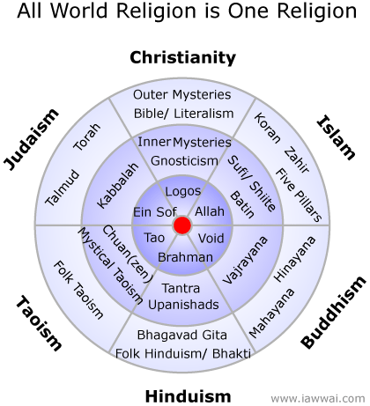

This diagram is from a book titled “Quest” by Wai H Tsang. And shows the relationship between various religions. He hypothesises that all mankind is God.
This diagram is meant to show that the common truth behind all world religions is the idea that everyone is God. In the outer sections of the circle, we have the outer mysteries of religion which are the rules, the rituals and regulations. In the inner part of the circle is depicted the mystical heart of each religion, the mystical practices and disciplines designed to bring people into union with God. Towards the centre we find God. The ultimate truth and ground of all beings. Though God is given different names, the assertion here is that all the different labels are referring to the same thing.
There are so many versions and sub-versions surely they cannot all be a unique God! No wonder the men writing the 10 commandments put in the one which says there shall not be any other Gods before me.
Remember that Moses’s 10 commandments were like the rules in the Egyptian Book of the Dead and Moses's life had been as the son of a Pharaoh.
Here is another concept of God, this one is also man-made.
Anthony Levandowski former Google executive and founder of Way of the Future, a new church based on the religion of artificial intelligence (from an interview by Mark Harris, Backchannel/Wired.
November 15, 2017: "Inside the First Church of Artificial Intelligence”.)
what is going to be created will effectively be a god. It's not a god in the sense that it makes lightning or causes hurricanes. But if there is something a billion times smarter than the smartest human, what else are you going to call it? And this time you will be able to talk to God, literally, and know that it’s listening.

Words.
Words and language are the tools of philosophers. Wittgenstein (1889-1951), an influential Austrian philosopher, put forward what some people considered to be a radical thesis. He said, "The problems of philosophers arise in consequence of fundamental errors in the use of language." Language is the instrument we use in the formation and communication of ideas and is therefore of central importance to philosophy. The difficulty is that when you transmit a thought, you use words that are clear to you, but which may not hold the same meaning for your listener. Your listener tends to understand your words in his terms of reference, not yours, and distortion creeps in. Words create ideas that we can or can not accept, words govern ideas, and words create our mental pictures.

Moral Compass:
What then is our moral compass?
The dictionary defines a moral compass as a person's ability to judge what is right and wrong and act accordingly. Some people also define it as a set of values that guide our decision-making, affect our actions, and define us as a person. In essence, a moral compass is just as its name suggests. In Freemasonry, we often refer to the symbology of the compass as setting bounds on our behaviour.
Evidence suggests that people who have a healthy functioning moral compass are more grounded, focused, content with life and productive. They also seem to have more nurturing and positive relationships with people around them and their environment. They minimize harm to this world and maximize their contributions. Does this sound like the description of the sort of man we should welcome into Freemasonry? Even if he does not believe in a deity.

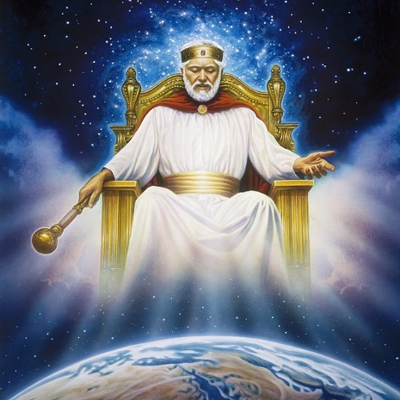
Belief: -
I will now look at belief. Belief has been thought to have an aim, that aims toward truth and knowledge. How many people still believe that the GAOU is an old man with a beard wearing flowing robes and sitting on a throne up in the sky?
Belief, the noun and believe the verb are words that are sometimes used in error and out of context.
I have used the word belief several times so far. So, what then is a belief? What is the difference between Believe and Belief?
Believe is a verb that is simply used for accepting the truth. ... Belief is a noun that is generally used for acceptance/confidence in the truth, faith, or trust. When you want to understand something, what appeared to be simple can get complicated. We could say that belief is an assumed truth!
From Wiki, Belief is the state of mind in which a person thinks something to be the case with or without there being empirical evidence to prove that something is the case with factual certainty
When you study the root of the word belief you gain a greater understanding of its depth and meaning. The true definition of belief will show you why our beliefs are so powerful. The word belief comes from two words.
Be and lief
Be: comes from being, which is a state of existence. To be is to live.
The second word lief comes from the Indo-European word leubh which means – love.
So when you put them together it changes the entire idea of the word belief. Belief then means to be in love with. Would you believe that?
Contemporary analytic philosophers of mind generally use the term “belief” to refer to the attitude we have, roughly, whenever we take something to be the case or regard it as true. To believe something, in this sense, needn't involve actively reflecting on it:
Therefore, beliefs are not necessarily what is true, or factual in the real world. The power of each belief comes only from the individual believer.
So why then should we as Regular Freemasons demand a belief in a Supreme Being? As can be seen from the above, belief is a relative state of consciousness that is abstract. Whereas a high moral compass is a tangible measurable trait.
So, what then is a fact? A Fact is the representation of reality as it is.
If this is so, what then is the truth? Truth is what is believed to be a fact by a person.
That means you can believe whatever you want to believe. If you believe it to be true, it will be true for you and your life.
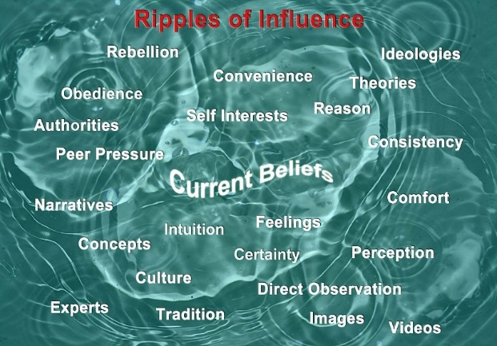
We are influenced by many factors that ripple through our minds as our beliefs form, evolve, and may eventually change.
To those searching for truth- not the truth of dogma and darkness but the truth brought by reason, search, examination, and inquiry, discipline is required. For faith, as well-intentioned as it may be, must be built on facts, not fiction -faith in fiction is a damnable false hope. -Thomas A. Edison
A belief is an internal thought or memory which exists in one's mind. Most people accept that for a belief to be knowledge it must be, at least, true and justified. Broadly speaking, knowledge is objective truth while belief is subjective truth.

Religion: -

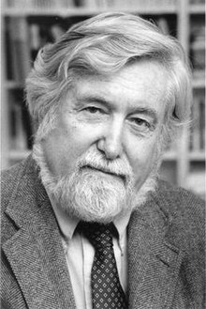
This then brings me to look at Religion. Is there just one definition of religion? There is not, Philosophers do not agree and in research, there are many different definitions, true, but all seem to hinge on the superhuman, belief, organized, ritual and more.
Here is one from Clifford Geertz. 1926-2006 Expert on cultural symbols.

The system of symbols which acts to establish powerful, pervasive, and long-lasting moods and motivations in men by formulating conceptions of a general order of existence and clothing these conceptions with such an aura of factuality that the moods and motivations seem uniquely realistic.
Freud stated that: - Religion is comparable to infantile neurosis.
Religion can be understood as a religare [to re-bind] also means union, also Yoga (Sanscrit yug) means union. Union with Divinity?
Nobel laureate and philosopher Bertrand Russell said:
‘Men are born ignorant not stupid, they become stupid by education.’
Most religious people think their morality comes from their religion. However, studies have shown that people often change what they say God wants with what they think is right. They manipulate their religious belief to suit their moral compass. And deeply religious people often wonder how atheists can have any morality at all, atheists do have a moral compass that may differ from that of a religious person.
Every Mason is a sincere seeker of light, of all light that allows him to advance in his search for truth. A good Mason must be tolerant of the freedom of thought of all laymen, he must be tolerant of the beliefs and dogmas of the profane world. He, therefore, has a highly developed moral compass. Is this not what our order deserves in our members?

Ideology:
Ideology refers to a set of beliefs and doctrines that back a certain social institution or an organization. Personal ideology is an individual's philosophy of how life should be and of what forces influence human living. A person’s ideology will have a direct bearing on their moral compass
We then can describe religion as collections of ideas, practices, values, and stories that are all embedded in cultures and not separable from them.

Just as religion cannot be understood in isolation from its cultural (including political) contexts, it is impossible to understand a culture without considering its religious dimensions. In the same way, that race, ethnicity, gender, sexuality, and socioeconomic class are always factors in cultural interpretation and understanding, so too is religion.
There are very fundamental differences between philosophy and ideology. Ideology refers to a set of beliefs and doctrines that back a certain social institution or an organization, as above, and in other words, ideology is aimed at changing the world, whereas philosophy is aimed at seeking the truth.
Do any of these definitions fit Freemasonry?

Philosophy.
Philosophy is where I would place the true aims of Freemasonry and where I believe they should be. As Masonic researchers do we not say that we seek the truth of Masonic Light?
Freemasonry is an institution founded on eternal reason and truth; whose deep basis is the civilization of mankind, and whose everlasting glory it is to have the immovable support of those two mighty pillars, science and morality. George Washington
This is from Bertrand Russell taken from his lecture “Why I am not a Christian” given at Battersea Town Hall in 1927 and the last paragraph “What We Must Do”.
A good world needs knowledge, kindliness, and courage; it does not need a regretful hankering after the past or a fettering of the free intelligence by the words uttered long ago by ignorant men. It needs a fearless outlook and free intelligence. It needs hope for the future, not looking back all the time toward a past that is dead, which we trust will be far surpassed by the future that our intelligence can create.
In other words, do we not need men with morality (a high moral compass) as part of their creed?
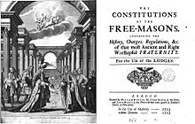
To answer this, let us look at our Constitution.

Freemasons Constitutions.
Are there any words in our constitutions that lead us to say we should have men with a high moral compass?
It seems only natural, that with the commissioning in the early 1700s by Deputy Grand Master John Theophilus Desaguliers, a minister of religion, (he was also a brilliant scientist) and James Anderson also a minister of religion to write a history and a set of rules to govern the new Grand Lodge of England that they would have a leaning toward their particular religion. Or was Anderson just the compiler? See footnote 12
We must keep in mind that the society of the early 1700s within which the genesis of Freemasonry occurred was a far different one than that of today. London was rife with political intrigue with a move to advance the Stuart cause. Time was still measured by the Julian calendar with the new year being Lady Day on 25th March.
For example, in 1717, one of the four founding Lodges of Grand Lodge was The Rummer and Grapes Lodge. It had on its books no less than thirteen members who were aristocrats; approximately twenty who were members of The Royal Society; over twenty more were magistrates, and almost a third were members of Parliament. Some even had military rank, including two general officers and at least ten colonels. Five of the leading members had direct blood links to the Crown; four were grandsons of Charles II.
This was the membership of Freemasonry at that time. Could it be said that they were elitist?.
Changes in agriculture were heralding the industrial revolution. In 1717 there were 18,475 babies born and 23,446 people buried. The average life expectancy age of a gentleman was in the mid-40s and of the poor only half that. The figures are no doubt brought about by the huge number of children who died before the age of 5. In certain districts, the infant mortality rate reached 75% of all births. During the 1700s more people died in London than were baptised every year. It was only the steady flow of migrants coming to the city from rural areas, that prevented London's population from declining dramatically. On top of that, there were 91 men and 18 women hanged that year (1717).
All in all not a good time for your average man. This was also the time when the production and consumption of gin was at an all-time high and no doubt assisted the rise in the early death of many, but at least it did not kill as many as did the bad water of the time. We must then view the rise of Grand Lodge Freemasonry and the rise of its membership within the history of the time.
Freemasonic men were the crème de la creme of the population. Only Royalty, the rich and famous, clergy and those who could afford it, like members of the Royal Society were Freemasons.
The history of Masonry as written by Anderson and others, proving fanciful and just a figment of his imagination or was it supposed to be taken as an allegory? These myths were not as specifically masonic, as they first may seem. They are based upon relatively common beliefs by the people of the early 18th century about the creation and development of mankind – and – much more important especially for noblemen – are based upon the belief about the heredity of virtue through a bloodline.
The authors of the 1723 Constitutions of the Free-Masons held the position that they were upholding the ancient traditions passed down to them through Masonic history, its documents, and traditions. It follows that they must have had access to earlier documents, so were rewriting the rules and regulations and not starting from the beginning.
What we know as Anderson’s Constitutions, were based on the Old Masonic Manuscripts (also called “Gothic Constitutions”) and on the General Regulations which had been compiled first by George Payne in 1720. The full title of the 1723 edition was The Constitutions of the Free-Masons, Containing the History, Charges, Regulations, &c. of that most Ancient and Right Worshipful Fraternity, for the Use of the Lodges.
From the original cover, the printer's name is there as are also the names John Senex and John Hooke. Anderson's name does not appear until page 74
Here is a copy from the (First edition of) 1723 Constitutions of that part headed Concerning God and Religion.
I. Concerning GOD and RELIGION.
A Mason is oblig’d by his Tenure, to obey the moral Law; and if he rightly understands the Art, he will never be a stupid Atheist, nor an irreligious Libertine. But though in ancient Times Masons were charg’d in every Country to be of the Religion of that Country or Nation, whatever it was, yet ’tis now thought more expedient only to oblige them to that Religion in which all Men agree, leaving their particular Opinions to themselves; (my emphasis) that is, to be good Men and true, or Men of Honour and Honesty, by whatever Denominations or Persuasions they may be distinguish’d ; whereby Masonry becomes the Center of Union, and the Means of conciliating true Friendship among Persons that must else have remain’d at a perpetual Distance.
I particularly like that part where it says leaving their particular opinions to themselves.
Does this part describe in detail a man of high moral compass? The expression Moral Compass was not used until 1824, but its definition can be seen in this part of the constitution.
At the time of forming the Grand Lodge in 1717, the UK had been and was still in a state of political and religious ferment. There were Catholics long having been on the way out as were the vestiges of the Puritans, and the Anglicans made up 92% of the population with only ·3% having no religion. Would it not be stupid to admit to being an Athiest in these times?
What also is a Libertine? A libertine is one devoid of most moral or sexual restraints, which are seen as unnecessary or undesirable, especially one who ignores or even spurns accepted morals and forms of behaviour sanctified by the larger society. However, it also originally meant a freethinker or Deist. Derived from the Latin "libertinus," a man that was once a bondsman but who has been made free, it was metaphorically used to designate one who had been released, or who had released himself from the bonds of religious belief and become in matters of faith a doubter or denier. The sort of man not wanted by our Fraternity of good men and true. Though, interestingly, both (Atheist and Libertine) are tarred with the same brush in this Constitution.
History shows us that many could have been described as Libertine in one sense or another who claimed a belief in a supreme being and were, Kings, Popes, Cardinals, Bishops, Politicians, priests and some Freemasons who possessed a low or non-existent moral compass.
The current UGLE constitutions accept that from 1717 the aims as stated came into being but in listing the principal editions of the Book of constitutions start at the issue, which is the 6/7th Edition of the Constitutions and dated 1815. This is, of course after the unifying of Grand Lodges in the UK in 1813. Our brothers then must have felt the need to change the constitutions then, which is alluded to in section 2 below.:
2. In view of representations which have been received, and of statements recently issued which have distorted or obscured the true objects of Freemasonry, it is once again considered necessary to emphasize certain fundamental principles of the Order.
What representations and by whom is not known, or at least I have been unable to find out
The following states a Belief principle as if it were from the beginning and is from the 1815 version of the Constitution. As shown above, it was not in the first edition (1723) of the Constitutions:
A Mason is obliged, by his tenure, to obey the moral law; and if he rightly understand the art he will never be a stupid atheist nor an irreligious libertine. He, of all men, should best understand that GOD seeth not as man seeth; for man looketh at the outward appearance, but GOD looketh to the heart. A mason is, therefore, particularly bound never to act against the dictates of his conscience. Let a man's religion or mode of worship be what it may, he is not excluded from the order, provided he believe in the glorious architect of heaven and earth, and practise the sacred duties of morality. Masons unite with the virtuous of every persuasion in the firm and pleasing bond of fraternal love; they are taught to view the errors of mankind with compassion, and to strive, by the purity of their own conduct, to demonstrate the superior excellence of the faith they may profess. Thus masonry is the centre of union between good men and true, and the happy means of conciliating friendship amongst those who must otherwise have remained at a perpetual distance.
Here we have to miss the definition of that Religion in which all men agree: “to be good men and true, or Men of Honour and Honesty” or one could say of a high moral compass.
It is also in these early times that the breakaway from the English way of Freemasonry by the French occurred. The Grand Orient of France was created in Paris in 1736 Its Constitution was the model of Anderson’s original Constitution of 1723.
Changes to this constitution (Andersons) were first made in England regarding a belief in a Supreme Being or the GA of the U and the placing of the Bible on the altar. The Bible is not mentioned in Masonic Rituals until 1724 and it was in 1760 that Preston moved that it be considered as one of the Great Lights of Freemasonry. At this time the French stayed with the original constitution. There was no problem with this, and French Masons were not considered Godless or Atheists. To be atheistic the French would have had to state “there is no God” they did not say this. They did say “Masonry excludes no one on account of his beliefs” It is interesting to note that the proposer of the idea to suppress the GA of the U was a protestant clergyman and he stated “In suppressing the formula respecting the GA of the U we did not mean to replace it by a materialistic formula. None among us in proposing this suppression thought of professing atheism or materialism, and we declare formally and emphatically that we had no other end in view than to proclaim absolute liberty of conscience”
I do not want to be considered as one who thinks it is wrong for a man to hold a belief in a deity but as one who seeks to hold a belief that there are many good men and true who do not hold the same belief as other Freemasons but should also be welcomed within our fold. I will again quote from Anderson's constitution of 1723 “yet it is now thought more expedient only to oblige them to that religion in which all men agree, leaving their peculiar opinions to themselves; that is to be good men and true, men of honour and honesty by whatever denominations or persuasions they may be distinguished”
This then is where the Grand Orient of France went back to after the English amended their constitution to include the GA of the U.
A man of high Moral Compass would fit into that described as making a good Mason.

The volume of Sacred Law
The Bible referred to by Freemasons, as the Volume of the Sacred Law [VSL], is always open in Lodges. Item 4 of the Constitution states in part. Every Candidate is required to take his Obligation on that book or on the Volume which is held by his particular creed to impart sanctity of oath or promise taken upon it.
Having taken the great and solemn obligation of a Freemason, the candidate is restored to the blessing of material light. He is then told that we acknowledge "three great, though emblematical, lights in Freemasonry. They are the Volume of the Sacred Law, the Square and the Compasses." Thus, the first, and the most important revelation to the Candidate in Freemasonry, is to the greatest of all lights, "The Volume of the Sacred Law."
Its presence, however, is no more than a symbol, a representative of all the great books of the religious teachings, which have significance to particular groups of people
In some Jurisdictions, other works replace the Bible on the altar. Singapore Lodge, a Lodge working under the English Constitution, uses no fewer than six of the VsSL of various faiths.
As one Scottish Grand Lodge authority puts it: "The Volume of the Sacred Law, no matter though it be our Bible or the Sacred Writings of the Hindu, the Zendavesta of the Parsee, or the Koran of the Mohammedan, typifies the Mind or Will of the GAOTU, the Great First Cause - the Creator and Preserver of the Universe - the Great Life-Giver, that Great Unknown and Unknowable which is manifested in His Universe. It is a symbol and a symbol only, and it is shown as supporting the other two symbols, the Square and Compasses (my emphasis) ”.
At one time within my Lodge, we Initiated a man who was a Buddist. When asked what VSL he wanted to use, he said any book will do. The book is not important the promise is.
yet ’tis now thought more expedient only to oblige them to that Religion in which all Men agree, leaving their particular Opinions to themselves.
Does this statement from the UGLE Constitutions not say that a man's belief system is a personal belief and not one forced on him? And what is that Religion that all men agree to? Could it be described as his moral compass?
But then Freemasonry claims that it is not a Religion! I may then ask, why do we read passages from the KJ Bible when opening the Lodge and in each degree? We must also realise that much of our Ritual is based on Biblical passages. Why? Is not “The Good Book” to be an education in the right behaviour? Yes, it contains lessons in good behaviour but also some abhorrent behaviour that we as Freemasons use in our Ritual. Our Ritual remains as that conceived by our early Christian brethren and is used no matter what other VSL is used. Why? Is it not, for our use, an allegory? Is not our order based on symbols and allegory? Is that why our order has become universal and our Ritual universally accepted? I ask you to ponder on these questions.
Surely a promise can be made and kept by holding our heart or by vowing on our book of constitutions? Or as is done elsewhere by placing the hand on a square?
Despite the importance we, as Speculative Freemasons, attach to the VSL, we are aware that the records that have come down to us do not refer to the Bible or sacred writings or whatever name it is known by as occupying a particular place in Lodge ceremonial before the late 1600s. This does not mean to say that there was no religious background to the ceremonies of our Masonic forebears.
The Regis Manuscript, probably compiled by a Catholic priest and taken from earlier manuscripts, refers to our duty to God and is considered a work written for masons, as are later manuscripts, the Cooke, and others.
It should also be remembered that the first complete Bible in Britain was not printed until 1526, and only fifty years later would not have been widely available, nor able to be read by most people. Male illiteracy, at that time, was close to 90% and in 1717 it was around 40% As well as the inability to write or sign their name.

What is an Oath/Vow?
Every Candidate is required to take his Obligation on that book or on the Volume which is held by his creed to impart sanctity to an oath or promise taken upon it. So how do we define an oath?
A call upon a revered person or thing, to witness one's determination to speak the truth, to keep a promise, etc.: to testify upon oath. a statement or promise strengthened by such an appeal. a formally affirmed a solemn appeal to a deity, or to some statement or promise accepted as an equivalent of an appeal to a deity or to a revered person or thing; affirmation.
It is therefore not essential to take an oath on any book, this is seen in current jurisprudence. An oath with a hand on the heart or the book of Constitutions or even a physics book would suffice. Would it have the same impact? Here we would again have to look at the person's belief. I am sure that there are men out there who revere a book on Physics with the same awe as those who revere a Bible.

Who are believers?
To quote Mark Twain “Faith is to believe in what you know for sure is not true”. And anonymous,
Faith, in its anthropological sense, is a human need and amounts to confidence or trust in a person or institution.
Faith sees the invisible,
Believes the unbelievable and
Receives the impossible.
Census results from the UK in 1983 showed that 31.4% of the population had no religion. In 2010 37% of people had no religion and by 2013 this had risen to 51%. And by 2017 53%. Other surveys show that whilst Anglican membership declined from 40.3% In 1983 to 16.3% in 2014. In 2014 60% of British people described themselves as having no religion. These figures are from the census.
The latest figures from YouGov.co.uk website Over half (55%) of Britons say they do not belong to any particular religion.
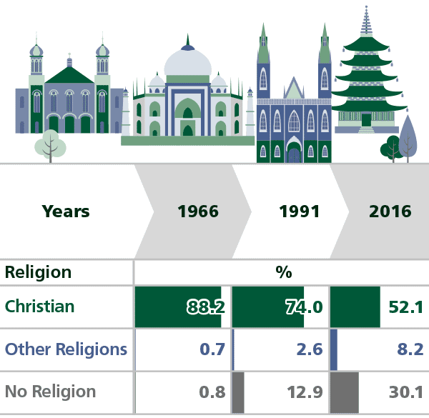
In Australia, (see table left) the 2016 Census showed those ticking “no religion” rose from 22.6 per cent in 2011 to 30.1 per cent in 2016 — nearly double the 16 per cent in 2001 or the .8% in 1966.
These figures show the changing nature of people’s beliefs. In the UK and here in Australia and New Zealand we have a rather large change in what people believe or have faith in.
That our Freemasonry demands both a single-sex membership and belief for a Supreme being is excluding not only 50% of the population, female, but also a large percentage of non-believers of the remaining 50% give or take.
Note: The 2021 Australian census figures are not available as of March 2022. HL
Among all adults in Britain, only 15% consider themselves to be Anglican, compared with almost one in three at the turn of the century, according to BSA data. Nine per cent overall identify as Catholics, 17% as “other Christian” and 6% say they belong to non-Christian religions.
More generally, 53% (September 2017) of all adults describe themselves as having no religious affiliation, up from 48% in 2015. The latest figure is the highest since the BSA survey began tracking religious affiliation in 1983 when 31% said they had no religion.
A study of Generation Z Australian youth (13-18 years) shows that 52% indicate no religion, they are now known as Nones! It is from this group that we will seek Freemasons of the future Do we think that these Nones are stupid Atheists and irreligious libertines with no moral compass? I would suggest that their actions which in the main show care for fellow humans and animals indicate the following.
that is, to be good men and true, or Men of Honour and Honesty,

The Questions we need to ponder.

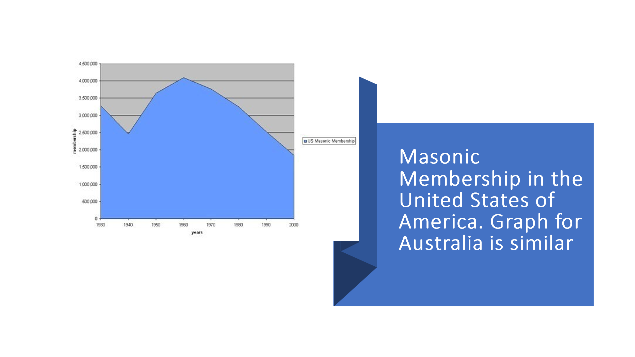
Will an insistence on the belief in a Supreme Being accelerate Freemasonry’s demise? Freemasonry is in decline which is a fact not a belief.
Is a belief in a Supreme being the only way a man can be called “to be good Men and true, or Men of Honour and Honesty”, Grand Orient Lodges, who do not demand a belief in a supreme being, whose numbers are not declining, say not so. I also agree with this sentiment. Following is a quote from a member of the Grand Orient written in the 1800s
"The Grand Orient of France, while it respects all philosophical beliefs, insists upon absolute liberty of belief. This does not mean that we banish from our lodges the belief in God. (my emphasis) The United Grand Lodge of England on the contrary desires to make a belief in God in some manner compulsory. The Grand Orient of France is much more liberal since in proclaiming the absolute liberty of belief it permits to each one of its members the liberty to believe or not to believe in God, and by so doing desires to respect its members in their convictions, their doctrines and their beliefs. And.
"I can affirm that the Grand Orient of France is neither deist, atheist, nor positivist. All philosophical conceptions are represented within its body.
I again quote the original UGLE constitution. that is, to be good men and true, or Men of Honour and Honesty,

I in no way, am suggesting that a belief in a supreme being is or should be, a reason for not becoming a Mason but there is or should be room for a man who does not have this belief. A belief in a supreme being does not necessarily make a man a good man. History has proven this otherwise, many times over.
However, a man who has a high moral compass should be welcomed into our order. I ask, what real difference does a belief in a supreme being make?
Should we as “men of honour and honesty” be at least honest with our thinking and apply this to our Fraternity?
My brothers, I ask that you consider the questions I have raised here. I think that we have to consider where we are going “Beyond the Craft” and if there is a reason to change our direction then at least it should be part of our discussions.

Origin of Sociology as a Discipline Sambit Mallick 2015
Dictionary of Religion
http://www.iawwai.com/
Wikipaedia Belief, defined.
https://www.etymonline.com/word/belief
Stanford Encyclopaedia of Philosophy
Clifford Geertz, Religion as a Cultural System, 1973
Russell, Bertrand. Part II. Chapter XXI Thought in the 19th Century. A History of Western Philosophy. 1945. New York: Touchstone, May, 2007. 722. Print.
The general regulations were compiled first by George Payne in 1720 when he was Grand Master and approved by Grand Lodge on St. John Baptist's Day, 24th June 1721, at Stationer's Hall, London when Prince John Duke of Montagu was unanimously chosen, Grand Master.
Following his work on the 1723 Constitutions and recommended by Desaguliers whose scientific books he had published, Senex was rewarded with appointment as a Grand Warden, taking office in the year the Constitutions were published. Five years later Desaguliers sponsored Senex as a Fellow of the Royal Society.
Hooke and Senex are not known to have collaborated prior to the publication of the 1723 Constitutions and do not appear to have done so afterwards other than in connection with Ephraim Chambers’ Cyclopaedia, another book with Masonic links. Both men were Freemasons, Senex a member of the Lodge at the Fleece Tavern in Fleet Street (recorded in the 1723 list of members), and Hooke a Warden of the Lodge at the Fountain Tavern in the Strand, now Royal Alpha Lodge No. 10 (1725 list) Footnotes 19, 20 are from QC 121 2008 an article by Andrew Prescott
William Hunter was the printer, and why do the of names Senex and Hooke appear on the cover page and not James Anderson, who is mentioned way back on page 74, along with 60 other named individuals? These 61 names, including Anderson, are from the section entitled “Approbation.” The names listed, I assume, are in order of Masonic importance, only because they are not in alphabetical order, as one might presume. The word Approbation can be defined as, “an act of approving formally or officially.” Therefore, this was the final approval committee, which included Anderson. https://gnosismasonry.wordpress.com/2015/08/01/dissecting-the-1723-constitutions-of-free-masons-dispelling-revisionist-myths-2/
From 1723, the original Grand Lodge Constitutions.
Dictionary
The 1815 Constitution
Item 4 UGLE Constitutions
The Masonic Trowel. http://www.themasonictrowel.com/Articles/Freemasonry/philosophy_files/the_volume_of_sacred_law.htm
The Tyndale Bible generally refers to the body of biblical translations by William Tyndale ( c. 1494–1536). Tyndale's Bible is credited with being the first English translation to work directly from Hebrew and Greek texts.
David Mitch, “Education and Skill of the British Labour Force,” in Roderick Floud and Paul Johnson, eds., The Cambridge Economic History of Modern Britain, Vol. I: Industrialisation, 1700-1860, Cambridge: Cambridge University Press, 2004. p. 344.
Dictionary.com
The Guardian 5-9-2017, Harriet Sherwood.
2017 Study by Mary Lou Rasmussen, Gery Bouma et al Monash Uni
Our Constitution
Our Constitution

